PIZZA SALES SQL QUESRIES
- KPI’S
- Total revenue:
select sum(total_price) as total_revenue from pizza_sales;
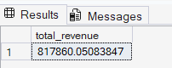
- Average Order Value :
select sum(total_price) /count(distinct(order_id)) from pizza_sales;
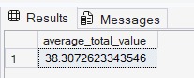

- Total Pizzas Sold :
select sum(quantity) as Total_Pizzas_Sold from pizza_sales;
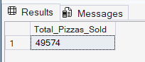
- Total Order :
select count(distinct(order_id)) as total_order from pizza_sales;
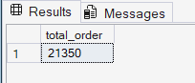
- Average Pizza per Order :
select cast(cast(sum(quantity) as decimal(10,2)) /
cast(count(distinct(order_id)) as decimal(10,2)) as decimal(10,2) )
as average_pizza_per_order from pizza_sales;
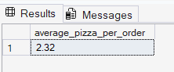
- Daily Trend
select DATENAME(DW, order_date) as order_day, Count(Distinct(order_id)) as Total_orders
from pizza_sales
group by DATENAME(DW, order_date)
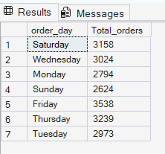
- Monthly Trend for Total Orders:
select DATENAME(MONTH, order_date) as Month_Name, Count(Distinct(order_id)) as Total_orders
from pizza_sales
group by DATENAME(MONTH, order_date)
ORDER by Total_orders DESC
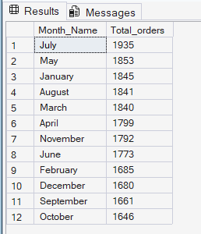
- Percentage of Sales by PIZZA Category :
SELECT pizza_category,
sum(total_price) * 100 / (SELECT sum(total_price) FROM pizza_sales)
as Percentage_of_Sales
from pizza_sales
GROUP BY pizza_category
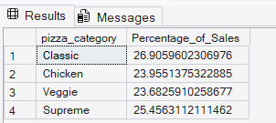
- Percentage of Sales by PIZZA Size:
SELECT pizza_size,
cast(sum(total_price) * 100 / (SELECT sum(total_price) FROM pizza_sales)
as decimal(10,2))
as Percentage_of_Sales
from pizza_sales
GROUP BY pizza_size
order by Percentage_of_Sales DESC
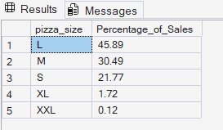
- Top 5 Best-Selling Pizzas (by revenue):
select top 5 pizza_name, sum(total_price) as Total_Revenue FROM pizza_sales
GROUP BY pizza_name
ORDER BY Total_Revenue DESC
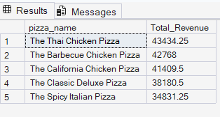
- Top 5 Bottom-Selling Pizzas (by revenue):
select top 5 pizza_name, sum(total_price) as Total_Revenue FROM pizza_sales
GROUP BY pizza_name
ORDER BY Total_Revenue ASC
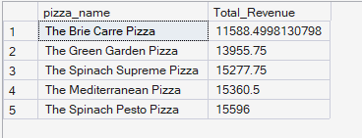
- Top 5 Best-Selling Pizzas (by quantity):
select top 5 pizza_name, sum(quantity) as Total_Quantity FROM pizza_sales
GROUP BY pizza_name
ORDER BY Total_Quantity Desc
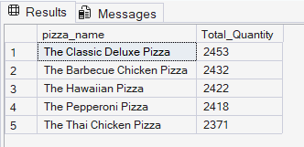
- Top 5 Bottom-Selling Pizzas (by quantity):
select top 5 pizza_name, sum(quantity) as Total_Quantity FROM pizza_sales
GROUP BY pizza_name
ORDER BY Total_Quantity asc
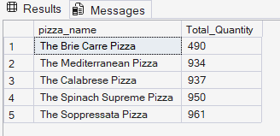
- Top 5 Best-Selling Pizzas (by orders):
select top 5 pizza_name, sum(Distinct(order_id)) as Total_Orders FROM pizza_sales
GROUP BY pizza_name
ORDER BY Total_Orders Desc
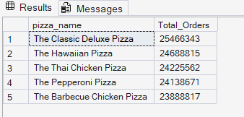
- Top 5 Bottom-Selling Pizzas (by orders):
select top 5 pizza_name, sum(Distinct(order_id)) as Total_Orders FROM pizza_sales
GROUP BY pizza_name
ORDER BY Total_Orders asc
